**Title: Micro-Controller with Embedded C**

**Sub Title: Digital Voltmeter**

**Electronic Instruments Used:**

1. **LM3S9B92 Micro-controller**
2. **ADC converter**
3. **Probes**
4. **Voltage Source [+5V]**
5. **PC-with Code Composer Studio V5**
6. **USB cable**
7. **Base Board**
8. **Current Source**
9. **Comparator Board**
10. **Digital Display[ BCD]**
11. **Oscilloscope**

**Short Description of Experiments:1**

A digital-to-analog converter (D/A) is a device which is used to handle the conversion of a digital value to an analog signal. The digital value is usually represented by a binary code, while an analog signal can be current, voltage, or electric charge. The transfer characteristics of the internal D/A converter were given in the assignment. The method that was used in order to develop a C program for such a converter is called weighting conversion method. This method is based on the following: first, an output is a binary number with only MSB set. Then the comparison of the corresponding output voltage U-OUT with the input voltage UE is done. If U-OUT is less than UE, the voltage level at PG(0) is set to high level. If U-OUT is more than UE, the comparator puts out a low level. So, the decision whether the MSB should be cleared or not is determined. The sequence of these steps hold for all remaining bits and as a result we get a binary value which corresponds to the input voltage UE. Afterwards, the voltage is being output. Port(J) and port(E) are used for displaying three digits of this output. When the change of the digital input occurs, it takes some time for a comparator to come to a stable mode. In our program we should consider the delay for the comparator which is equal to 30µs.

**Codes For Experiment 1:[DAC – Digital To Analog Converter]**

#include "lm3s9b92.h"

***void wait()***{

int i =0;

for (i =0;i < 1000; i++)

{

}

}

***void timerConfig()***{

// configure Timer 0

SYSCTL_RCGC1_R |= (1<<16);

wait();

TIMER0_CTL_R &= ~0x0001; // disable Timer 0

TIMER0_CFG_R = 0x04; // 2 x 16-bit mode

TIMER0_TAMR_R = 0x22; // periodic mode + match enable

TIMER0_TAPR_R = 3-1; // prescaler PR= ceil((10ms*fCPU)/2^16)

}

***void ConfigSys()***{

// activate main oscillator at 16 MHz w/ external XTAL

SYSCTL_RCC_R = ((SYSCTL_RCC_R | 0x00000540) & ~0x000002B1);

SYSCTL_RCGC2_R |= (1<<3)| (1<<6)| (1<<8)| (1<<4); // Ports Activation respective PD-PG-PJ-PE

wait();

// Port D as out put

GPIO_PORTD_DEN_R |= 0xFF; // PD(0) enable (7:0)

GPIO_PORTD_DIR_R |= 0xFF; // PD(0) output (7:0)

// Port E as Output

GPIO_PORTE_DEN_R |= 0x07; // PE(0) enable (pin 3:0)

GPIO_PORTE_DIR_R |= 0x07; // PE(0) output (pin 3:0)

// Port G as input

GPIO_PORTG_DEN_R = 0x03; // PG(0) enable (pin 1:0)

GPIO_PORTG_DIR_R = 0x00; // PG(0) Input (pin 1:0) Comparator Input

// Port J as input

GPIO_PORTJ_DEN_R = 0xFF; // PJ(0) enable (7:0)

GPIO_PORTJ_DIR_R = 0xFF; // PJ(0) output (7:0)

timerConfig();

wait();

}

***void timerWait(unsigned short Usec)***{

TIMER0_TAILR_R = ((16*Usec)/3)-1; // ((16Mhz*Usec)/PR)-1 Here Usec should be 30Usec

TIMER0_CTL_R |= 0x0001; //Enable the Timer

while((TIMER0_RIS_R & (1<<0))==0)

{ // wait until the flag set

}

TIMER0_ICR_R |= (1<<0); //clear the interrupt flag

TIMER0_CTL_R &= ~0x0001; //Disable the Timer

}

***unsigned int approximation_func()***{

int i = 8;

unsigned int SAR = 0;

GPIO_PORTD_DATA_R = SAR;

timerWait(30);

while((GPIO_PORTG_DATA_R & 0x02)== 0x02 ){}

for(i = 7 ; i>=0;i--)

{

SAR |= 1<<i;

GPIO_PORTD_DATA_R = SAR;

timerWait(30);

if((GPIO_PORTG_DATA_R & 0x01)== 0){ //Uout greater than Ue

SAR &= ~(1<<i);

}

else { //Ue greater than Uout

}

}

GPIO_PORTD_DATA_R = SAR;

timerWait(30);

return SAR;

}

***void Display(unsigned int SAR)***{

int temp1 = 0,temp2 = 0;

int EN_0_msb=0,EN_0_lsb=0,EN_1_msb=0,EN_1_lsb=0,debugflag;

float Ulsb = 5000/256;

int Uout = 0;

Uout = (SAR * Ulsb);

temp1 = Uout % 100;

EN_0_lsb= (temp1 % 10) ;

EN_0_msb= (temp1 / 10);

temp2 = Uout/100;

EN_1_lsb= (temp2 % 10) ;

EN_1_msb= (temp2 / 10);

wait();

GPIO_PORTE_DATA_R |= 1<<0;

GPIO_PORTJ_DATA_R=(EN_0_msb<<4)|EN_0_lsb;

debugflag = (EN_0_msb<<4)|EN_0_lsb;

GPIO_PORTE_DATA_R &= ~(1<<0);

wait();

GPIO_PORTE_DATA_R |= 1<<1;

GPIO_PORTJ_DATA_R= (EN_1_msb<<4)|EN_1_lsb;

GPIO_PORTE_DATA_R &= ~(1<<1);

wait();

}

***void main(void)*** {

unsigned int SAR =0;

ConfigSys();

while(1){

GPIO_PORTE_DATA_R = 0x04;

timerWait(30);

GPIO_PORTE_DATA_R = 0x00;

SAR = approximation_func();

wait();

Display(SAR);

}

}

**Picture Taken From Oscilloscope :**

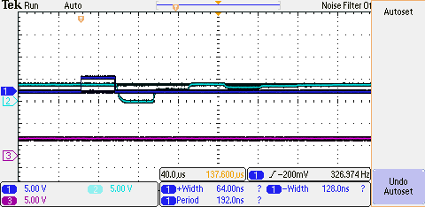

**Fig1: For Input Voltage [UE] Comparison with Input of Port D (Successive approximation)**

**Pictures taken During Lab : For Experiment 1: DAC**

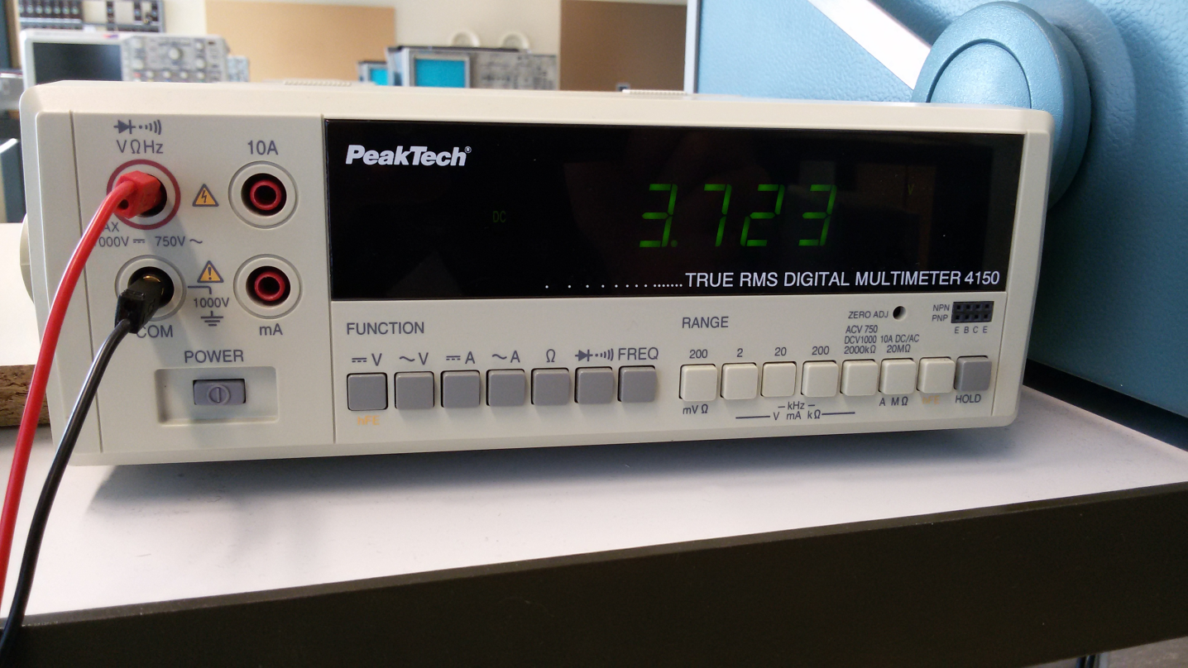

**Fig2: Selected Signal From Current Source to be Measured**

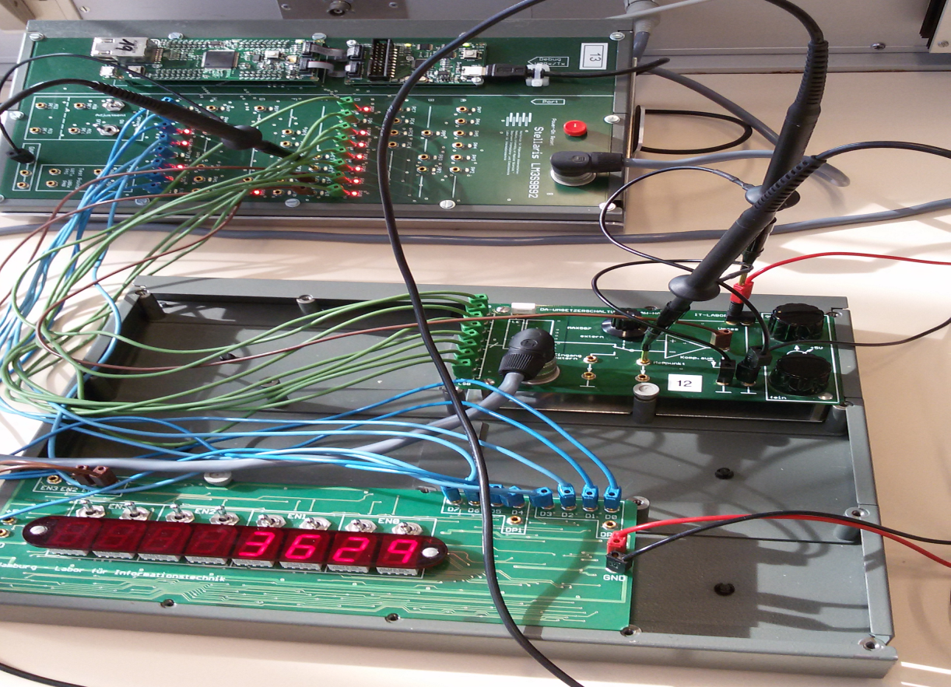

**Fig3: External Measurement Of Selected Signal Using Weighting Conversion Method**

**Codes For Experiment 2:[ADC – Analog To Digital Converter]**

#include "lm3s9b92.h"

**void wait(void){**

int i =0;

for (i =0;i < 1000; i++)

{

}

}

**void timerConfig(){**

// configure Timer 0

SYSCTL_RCGC1_R |= (1<<16);

TIMER0_CTL_R &= ~0x0001; // disable Timer 0

TIMER0_CFG_R = 0x04; // 2 x 16-bit mode

TIMER0_TAMR_R = 0x22; // periodic mode + match enable

TIMER0_TAPR_R = 3-1; // prescaler PR= ceil((10ms*fCPU)/2^16)

}

**void timerWait(unsigned short Usec)**{

TIMER0_TAILR_R = ((16*Usec)/3)-1; // ((16Mhz*Usec)/PR)-1 Here Usec should be 30Usec

TIMER0_CTL_R |= 0x0001; //Enable the Timer

while((TIMER0_RIS_R & (1<<0))==0)

{ // wait until the flag set

}

TIMER0_ICR_R |= (1<<0); //clear the interrupt flag

TIMER0_CTL_R &= ~0x0001; //Disable the Timer

}

**void ConfigSys(void)**{

// activate main oscillator at 16 MHz w/ external XTAL

SYSCTL_RCC_R = ((SYSCTL_RCC_R | 0x00000540) & ~0x000002B1);

SYSCTL_RCGC2_R |= (1<<8)| (1<<4); // Ports Activation respective PJ-PE

**wait();**

// Port E as Output

GPIO_PORTE_DEN_R |= 0xFF; // PE(0) enable (pin 3:0)

GPIO_PORTE_DIR_R |= 0x03; // PE(0) output (pin 3:0)

// Port J as input

GPIO_PORTJ_DEN_R = 0xFF; // PJ(0) enable (7:0)

GPIO_PORTJ_DIR_R = 0xFF; // PJ(0) output (7:0)

**timerConfig();**

}

**void Display(unsigned long Uout)**{

int temp1 = 0,temp2 = 0;

int EN_0_msb=0,EN_0_lsb=0,EN_1_msb=0,EN_1_lsb=0;

temp1 = Uout % 100;

EN_0_lsb= (temp1 % 10) ;

EN_0_msb= (temp1 / 10);

temp2 = Uout/100;

EN_1_lsb= (temp2 % 10) ;

EN_1_msb= (temp2 / 10);

**wait();**

GPIO_PORTE_DATA_R |= 1<<0;

GPIO_PORTJ_DATA_R=(EN_0_msb<<4)|EN_0_lsb;

GPIO_PORTE_DATA_R &= ~(1<<0);

**wait();**

GPIO_PORTE_DATA_R |= 1<<1;

GPIO_PORTJ_DATA_R= (EN_1_msb<<4)|EN_1_lsb;

GPIO_PORTE_DATA_R &= ~(1<<1);

**wait();**

}

**void main(void)** {

unsigned long ulData = 0;

ConfigSys();

//deactivate digital GPIO for analog use

GPIO_PORTE_AFSEL_R = 0x80;//configure bit 7 to alternate function

GPIO_PORTE_DEN_R &= ~0x80;

//GPIO_PORTD activate analog input fuunction

GPIO_PORTE_AMSEL_R |= 0x80;//activate bit 7 as analog function

SYSCTL_RCGC0_R |= (1<<16);

// ADC0_SS0 configuration

ADC0_ACTSS_R &= ~0x0F; // disable all 4 sequencers of ADC0

ADC0_SSMUX0_R |= 0x0000000; // sequencer 0, channel AIN0,in sequence,defines the

//sequence,analog channel to be sampled

ADC0_SSCTL0_R |= 0x0000002; // END2 set, sequence length = 1,defines the end of

//the sequence

ADC0_ACTSS_R |= 0x01; // enable sequencer 0 ADC0,activates the Sample Sequencers

while(1) {

ADC0_PSSI_R |= 0x01; // start ADC0_SS0,start ADC conversion

while ((ADC0_SSFSTAT0_R & (1<<8))==1) // wait for FIFO non-empty

;

// read ADC value from FIFO, convert in mV and display

ulData= ADC0_SSFIFO0_R*5000/1023;

//printf(" %04d\n",ulData);

**Display(ulData);**

}

}

**Pictures taken During Lab : For Experiment 2: ADC**

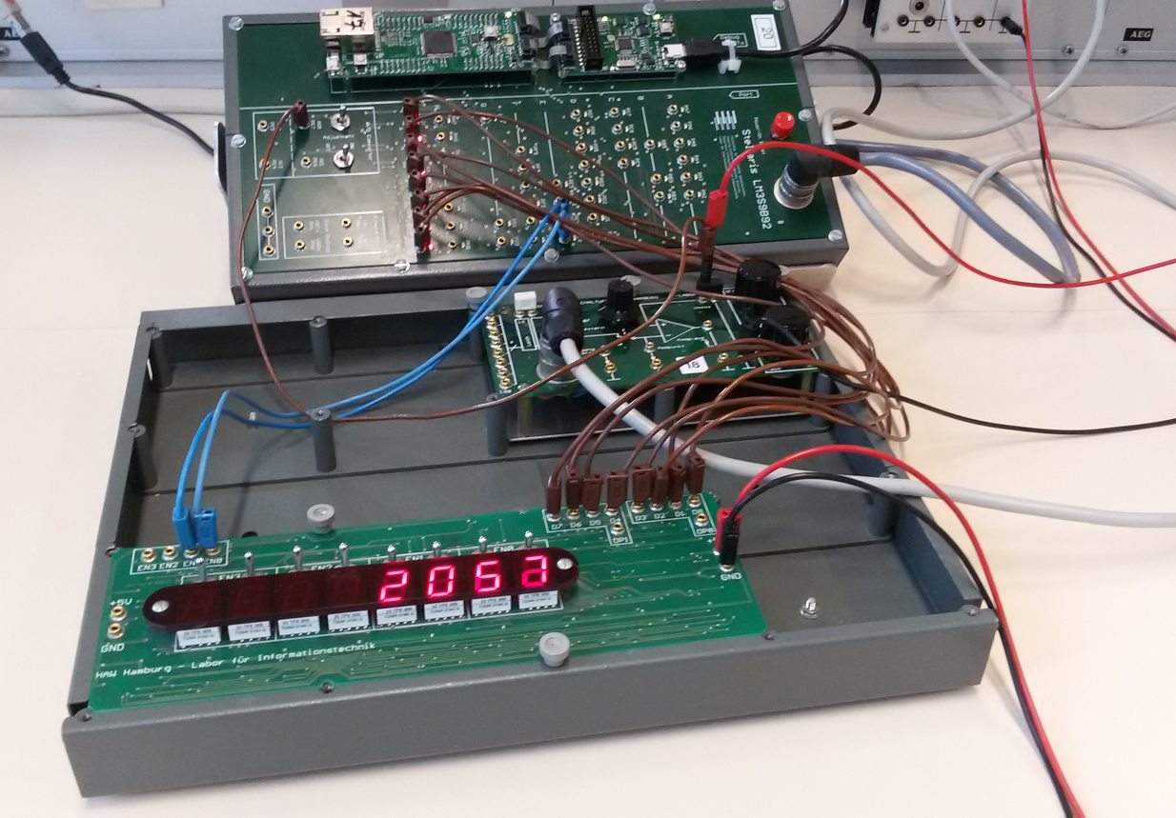

**Fig 4 : Display [ADC]**

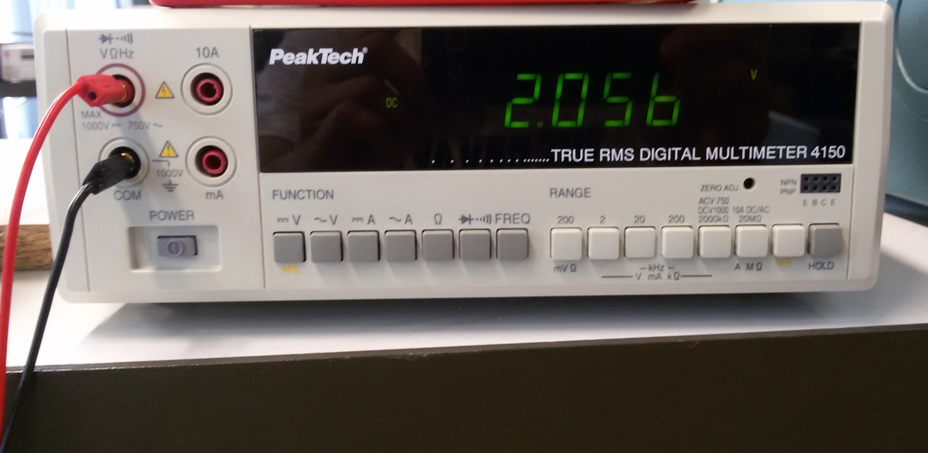

**Fig5: Display Of Input Analog Signal[Voltage] On A Volt Meter**

**Short Description Of Experiment 2:**

An analogue to digital converter is a device which is used to handle the conversion of an analogue value to digital signal. Usually analogue signal can be current, voltage etc. According to our experiment , we have chosen the Port ‘E’ (pin 7) as analogue signal input pin which is pre-defined as analogue pin in data sheet . As previous experiment 1 , we have configured Port ‘J’ (pins 7 to 0) as binary out-put of the Micro-Controller (LM3S9B92) which is given to the BCD display board. Here the BCD board shows the value in mille-volts (mV) after internally conversion by the C program .

Here as the internal conversion part, we have used a Micro-Controller (LM3S9B92) which consists of timer circuit, analogue to digital converter circuit etc. We have manipulated all those circuit using C program . As the main part of the analogue to digital conversion , we had to configure sample sequencer register, FIFO register and finally control register according to respective data sheet. And lastly we had to program in a way that we would able to display the value in mille-Volts.

**Conclusion:**

After the completion of the lab we are able to play with signals and also we knew the properties of analogue and digital signals. And also we are able to do their conversion. Mainly we knew about the functionality of Micro-Controller as well as it’s various operations to build a Digital Volt Meter in our lab.